

M.Sc. Computer Science and Engineering

Software Engineering 2 Project

**CLup - Customers Line-Up**

**Requirements Analysis and Specification Document**

Leoni Luca, Locarno Silvia, Minotti Luca

23rd December 2020

Version 1.0

GitHub Repository: https://github.com/lucagrammer/LeoniLocarnoMinotti

**Contents**

1 Introduction 3

1.1 Purpose 3

1.1.1 Goals 3

1.2 Scope 4

1.2.1 World and Shared phenomena 4

1.3 Definitions, Acronyms, Abbreviations 5

1.3.1 Definitions 5

1.3.2 Acronyms 6

1.3.3 Abbreviations 6

1.3 Revision History 6

1.4 Reference Documents 6

1.5 Document Structure 6

2 Overall Description 8

2.1 Product Perspective 8

2.1.1 Scenarios 8

2.1.2 Class Diagram 11

2.1.3 State Charts 11

2.2 Product Functions 12

2.3 User Characteristics 14

2.4 Assumptions, Dependencies and Constraints 14

2.4.1 Domain Assumptions 14

2.4.2 Dependencies 15

3 Specific Requirements 16

3.1 External Interface Requirements 16

3.1.1 User Interfaces 16

3.1.2 Hardware Interfaces 25

3.1.3 Software Interfaces 26

3.1.4 Communication Interfaces 26

3.2 Functional Requirements 26

3.2.1 Use Case Diagrams 26

3.2.2 Use Case Analysis 29

3.2.3 Sequence Diagrams 42

3.2.4 Requirements 46

3.2.5 Traceability Matrix 49

3.5 Performance Requirements 58

3.4 Design Constraints 58

3.4.1 Standard compliance 58

3.4.2 Hardware limitations 59

3.4.3 Any other constraint 59

3.5 Software System Attributes 59

3.5.1 Reliability 59

3.5.2 Availability 59

3.5.3 Security 59

3.5.4 Maintainability 59

3.5.5 Portability 59

4 Formal Analysis using Alloy 60

4.1 Alloy model 60

4.1.1 Signatures 60

4.1.2 Facts 63

4.1.3 Assertions 66

4.1.4 Analysis results 68

4.2 Alloy generated Worlds 69

5 Effort Spent 72

5.1 Leoni Luca 72

5.2 Locarno Silvia 72

5.3 Minotti Luca 73

6 References 74

**Chapter 1**

# 1 Introduction

This document constitutes the Requirement Analysis and Specification Document (RASD). Its purpose is to analyse the requirements that will lay the foundations of application services, to specify the application domain, the entities involved and their relationship, to clearly explain the objectives, the constraints and the features that are going to be implemented.

## Purpose

In the midst of the Coronavirus outbreak even shopping at grocery stores and supermarkets has proven to be a problem due to interpersonal distancing rules and building access restrictions. In fact, this typically results in long lines forming outside, which is less than ideal for avoiding crowds.

CLup is a software with the aim of managing in a simple but effective way the queues to access the stores, allowing customers to queue directly from the application and receive a notification just in time to physically reach the store, taking into account the time required to get to the shop using the indicated means of transport. Of course, fall-back options are available for people who don't have access to the required technology.

Furthermore, CLup allows customers to book a visit to a specific store on a specific date or, in the case that this is not possible, recommends alternative time slots or similar less crowded stores. Finally, customers can also be notified of the availability of slots in the day/time range in which they typically shop.

On the other hand, supermarket managers can easily keep access data under control and effortlessly ensure compliance with safety regulations.

### Goals

1. Allows Store Managers to regulate the influx of the people in their store
2. Allows Customers to line up from their home
3. Allows Guests to line up physically from a store
4. Allows Store Managers to keep access data under control
5. Allows Customers to be notified when their number is close to being called, considering the time to get to the shop
6. Allows Customers to book a visit to a specific store in a specific date
7. Suggests Customers alternative slots for visiting a specific store
8. Suggests Customers similar stores if the preferred one does not have slots available for booking in the near future
9. Provides Customers with periodic notifications about available slots in the day/time range they usually shop

## Scope

According to the World and Machine paradigm, introduced by M. Jackson and P. Zane, we can identify the Machine as the system to be developed and the environment, in which CLup will be used, as the World. The separation between these two concepts allows us to classify the phenomena into two different categories.

### World and Shared phenomena

***World phenomena***, events that take place in the real world and that the machine cannot observe.

* A person needs to buy goods at a supermarket.
* A person goes to a store without lining up from his home.
* A Store Manager wants to monitor the entrances to his shop.
* People deliberately disregard safety distances.

***Shared phenomena***, events that involve both the real world and the machine. They could take place in the real world and be observed by the machine, or they could occur inside the machine and have an impact in the real world.

***Shared phenomena: controlled by the world and observed by the machine***

* A Customer signs up to the Application or logs in if already registered.
* A Store Manager registers his store to the Application or logs in if already registered.
* A Customer books a visit to a specific store in a specific date.
* A Customer indicates the approximate expected duration of the visit.
* A Customer indicates the categories of items he intends to buy.
* A Customer uses a QR code to enter or leave the store.
* The Store Manager analyses the access data of his store.

***Shared phenomena: controlled by the machine and observed by the world***

* The System assigns a code to a Customer or a Guest that gives his position in the queue of a store.
* The System sends an alert to a Customer inviting him to reach the selected store.
* A Guest receives a paper ticket from a Physical Ticket Dispenser located in front of a shop.
* The System suggests to a Customer an alternative slot.
* The System suggests to a Customer similar less crowded stores.
* The System sends a notification to a Customer of available slots in a day/time range.

## 1.3 Definitions, Acronyms, Abbreviations

### 1.3.1 Definitions

* **CLup System (or “The System”)**: refers to the whole system to be developed.
* **CLup Services (or “Services”)**: refers to the functionalities offered by the CLup System, such as the queue management mechanism and the booking service.
* **CLup Application (or “The Application”)**: refers to the application that makes CLup Services available everywhere. In this document, this term is intentionally used in a generic way. How the application will actually be delivered (e.g., as a web app or as a mobile app) will be defined later in the Design Document of CLup.
* **QR** **Code**: quick response code, a type of matrix barcode.
* **Reservation ID**: a code that unequivocally represents either a position in the queue or a slot reservation.
* **Physical Ticket Dispenser**: a device connected to the CLup System that distributes paper tickets. It acts as a proxy for Guests. In this document we will intentionally refer to this object in a generic way. Clearly, how this will actually be achieved will be discussed in the CLup Design Document.
* **Guest**: a person who has not access to the CLup Application but still uses the CLup Service to access stores through the Physical Ticket Dispensers.
* **Customer**: a person that uses the CLup Application and its services to access stores and book visits.
* **Store Client**: either a Customer or a Guest.

### 1.3.2 Acronyms

* **RASD**: Requirement Analysis and Specification Document.
* **UML**: Unified Modelling Language.
* **API**: Application Programming Interface.
* **PTD**: Physical Ticket Dispenser.
* **GPS**: Global Positioning System.
* **API**: Application Programming Interface.
* **ETA**: Estimated Time of Arrival

### 1.3.3 Abbreviations

* **[G.i]**: i-th goal.
* **[R.i]**: i-th requirement.
* **[D.i]**: i-th domain assumption.
* **[UC.i]**: i-th use case.

## Revision History

|  |  |  |  |
| --- | --- | --- | --- |
| **Version** | **Date** | **Authors** | **Summary** |
| 1.0 | 5/12/2020 | Leoni Luca  Locarno Silvia  Minotti Luca | First release |

## Reference Documents

* Specification document: Project Assignment A.Y. 2020-2021.pdf
* Software Engineering 2 course slides
* Previous project examples:
* Specification document: Project Assignment A.Y. 2019-2020.pdf
* RASD to be analyzed.pdf
* IEEE Standard on Requirement Engineering (ISO/IEC/IEEE 29148)

## 1.5 Document Structure

This document is structured as follows:

1. ***Introduction*** - A general introduction to the goals, the phenomena and the scope of the system-to-be. It aims at giving general but exhaustive information about what this document is going to explain.
2. ***Overall Description -*** A general description of the product to be and its requirements. This section provides information that is explained in detail in Section 3.
3. ***Specific Requirements*** - All software requirements are explained using scenarios, use-case diagrams and activity diagrams. Non-functional and functional requirements are also mentioned.
4. ***Formal Analysis using Alloy -*** This section includes Alloy code that describes the model and shows its soundness and correctness.
5. ***Effort spent*** - Effort spent by all team members shown as the list of all the activities done during the realization of this document.
6. ***References*** - References to documents that this project was developed upon.

**Chapter 2**

# 2 Overall Description

## 2.1 Product Perspective

### 2.1.1 Scenarios

* **Scenario 1: *Simonetta discovers CLup***

Simonetta is really worried about the possibility of contracting Coronavirus and thus being able to endanger her daughter’s life, who unfortunately is immunocompromised. For this reason, Simonetta always wears the surgical mask and avoids crowded areas. What scares her the most are the long queues that form in front of supermarkets, which is why Simonetta is very happy when her colleagues introduce her to CLup. In fact, she immediately signs up as a customer by filling out a simple form with her personal data and her email. The young mother, finally, completes the registration by accepting the Terms and Conditions of the service and the Privacy Statement.

* **Scenario 2: *Steve and the technology***

Steve is an elderly man who has neither a smartphone nor an internet connection. However, this does not prevent him from using the CLup Services that the grocery store near his home has recently adopted. In fact, once he reaches the store, Steve presses a button of a Physical Ticket Dispenser and picks up his ticket. In this way, even if the wait is long, thanks to the estimation calculated by the System, Steve can still take a walk at the park next to the store without missing his position.

* **Scenario 3: *Filippo, the regular Customer***

Filippo, a well-informed young man, uses CLup from the day it was released. After a long workday, he finally arrives at home and opening the fridge he sadly realizes that it is quite empty. Therefore, he opens CLup and selects his usual supermarket in order to line up. The estimated waiting time is only thirty minutes, so he decides to line up and he selects he will go by foot. The Application gives him an electronic ticket containing the QR code needed to enter the store and a code that represents his position in the queue. After twenty minutes, he receives a notification from the Application that says that it is time to go, so he goes out to reach the grocery store. As soon as his code appears on the screen in front of the entrance, Philip shows his QR code to the reader and enters the supermarket.

* **Scenario 4: *Serena, the transfer student***

Serena is a transfer student in Milan. She usually goes to a local supermarket because it is difficult for her to carry the heavy shopping bags for a long way. For this reason, she always books a visit in order to have always her supermarket available. This week she has been very busy due to the mid-term exams and she forgot to book the visit in advance. Once Serena has finished the last exam, she opens the app and tries to book the visit to the supermarket for the next day. Unfortunately, the chosen day is unavailable, so CLup suggests her another available slot to go to the supermarket and another near grocery shop available at the date she selected. Serena picks up the first suggestion and decides to book a visit in another date at her usual supermarket.

* **Scenario 5: *Matteo, the busy man***

Matteo is a businessman. Usually, he goes to the supermarket on Tuesday evening. During the Covid-19 emergency, he lost a lot of time doing shopping, because everyone decided to go to the supermarket after work. Matteo is very organized, and, in order to optimize his time, he turned on the Periodic Notification service offered by CLup. His last visit was two weeks ago, and he has not booked the next one yet. CLup sends him a notification warning him about an available slot at his usual grocery store.

* **Scenario 6: *Michael, the Store Manager***

Michael is the Store Manager of Dunder Mifflin grocery store in Como. Dunder Mifflin is one of the major supermarket chains in Italy. After the official release of the last DCPM, all the stores on the Italian territory have to monitor the access to the buildings, with the aim of avoiding gatherings. The CEO of Dunder Mifflin decides to leverage the functionalities offered by CLup. All the Store Managers must register their store on the platform. Michael opens the CLup Application and selects the registration process, dedicated to the stores. He inserts all the information, reads the Privacy Statement and accepts the Terms and Conditions. He successfully completes the procedure. Now the store is registered. All the Customers can reach it on CLup.

* **Scenario 7: *A matter of shifts***

Philip is a young nurse who works at the Cantù hospital and he knows very well how important it is to avoid crowded areas. For this reason, he always books a slot in his favourite supermarket through CLup for the time he leaves work on Thursdays. However, due to the increase in Coronavirus cases and the shortage of healthcare personnel, the hospital has extended Philip's shifts for the entire week. The young nurse opens the CLup Application and in the section dedicated to his reservations presses the button to delete the one for this week. The slot is then available for other customers.

* **Scenario 8: *Frozen food for everyone***

Jane, who is the manager of a supermarket in Milan, has activated CLup only a few weeks ago. That’s why she is very curious to analyse the data of her store. After authenticating with her credentials, Jane accesses the statistics section by pressing a button. From the shown graphs, she immediately realizes that many of her clients are interested in the frozen food department, which is currently not very large. In order to reduce waiting times, she decides to work on an expansion plan for this section.

### 2.1.2 Class Diagram

This section details the class diagram of the System. It provides a high-level view of the main concepts on which the system is focused.

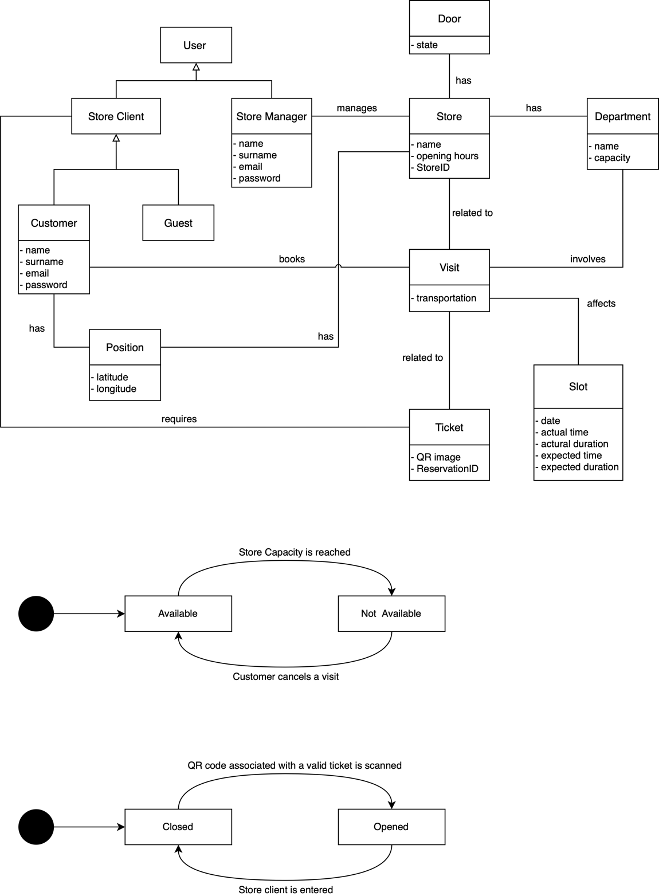

Class Diagram

### 2.1.3 State Charts

In the following, two simple state diagrams related to some concepts introduced in the previous section are shown. In particular, the first shows the state transitions of a sliding door, while the second focuses on the possible states of a time slot, intended as an hourly range.

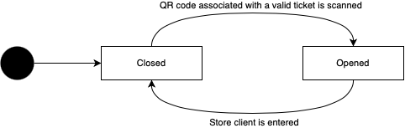

State Chart 1: Door Opening

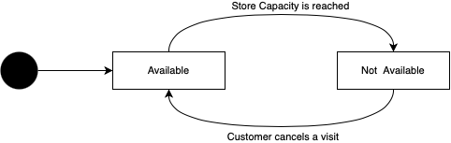

State Chart 2: Slot Availability

## Product Functions

* **Customer Registration:** CLup Application will allow Customers to register. These will register by entering all the required information listed in Table 1. When registering to the application, they will first declare to have read the Privacy Statement and secondly, they will have to accept the Terms and Conditions, which specifically include their consent to the acquisition and processing of their data.

|  |  |  |
| --- | --- | --- |
| **Information** | **Description** | **Mandatory** |
| Full name | The Customer’s full name | Yes |
| Email | The Customer’s email | Yes |
| Password | A password that meets the minimum-security requirements, i.e., it is at least 8 characters long and contains at least one number and one letter | Yes |

Table 1

* **Store Registration:** CLup Application will allow Store Managers to register the store. These will register by entering all the required information listed in Table 2. When registering to the application, they will first declare to have read the Privacy Statement and secondly, they will have to accept the Terms and Conditions, which specifically include their consent to the acquisition and processing of their data.

|  |  |  |
| --- | --- | --- |
| **Information** | **Description** | **Mandatory** |
| Full name | The Store Manager’s full name | Yes |
| Email | The Store Manager’s email | Yes |
| Store Name | The name of the store | Yes |
| Address | The address of the store | Yes |
| Opening hours | The opening hours of the store | Yes |
| Departments and capacity | The list of all the departments in the store and their maximum capacity | Yes |
| Store ID | A unique username for the store | Yes |
| Password | A password that meets the minimum-security requirements, i.e., it is at least 8 characters long and contains at least one number and one letter | Yes |

Table 2

* **Line Up from the Application:** From the list of available supermarkets, the Customer can select one and view the estimated waiting time. If he wishes he can queue directly from the Application, receiving an electronic ticket containing the QR code necessary to enter the store and a Reservation ID that represents his position in the queue. Moreover, if the Customer specifies the means of transport that he will use to reach the store, the Application will notify him when it is time to leave.

|  |  |  |
| --- | --- | --- |
| **Information** | **Description** | **Mandatory** |
| Means of transport | The means of transport the Customer will use to reach the store | No |

Table 3

* **Line Up from the PTD:** The Guest can request a ticket to line up directly from the PDT located near the entrance of a store. By pressing a simple button on the PTD, a paper ticket is emitted. This ticket contains the QR code needed to enter the store and a Reservation ID representing his position in the queue.
* **Book a visit:** The Customer can select a store between the registered ones. Once selected, the Customer can indicate the date and the time he would like to book for a visit. If the selected date and time is not available, the Application will suggest him the closest available slots for that store. In addition, the Application will recommend other stores available at the requested date.

|  |  |  |
| --- | --- | --- |
| **Information** | **Description** | **Mandatory** |
| Store | The store selected by the Customer | Yes |
| Date/time | The date and the time selected | Yes |
| Product’s categories | The list of all the categories of products he would like to buy | No |
| Expected duration | The expected duration of the visit | No |

Table 4

* **Periodic Notifications:** The Application provides the Customer periodic notifications of available slots in the day/time range he uses to visit the store.

## 2.3 User Characteristics

The actors of the application are the following:

* **Guest**: a single person who has not access to the CLup Application but still uses the “*Line Up*” Service through a PTD.
* **Customer**: a single person who has registered as a client to the CLup Application and can use all the Services it offers to access stores and book visits.
* **Store Manager**: a single person who is in charge of a grocery store or a supermarket (either belonging to a chain or independent) and who has registered it on the Application.
* **Unregistered User**: a single person who has not yet registered. He is only allowed to sign up or reach a store and use the “Line Up” Service through the PTD. In the first case he becomes either a Customer or a Store Manager depending on the type of membership, while in the second case he becomes a Guest.

## 2.4 Assumptions, Dependencies and Constraints

### 2.4.1 Domain Assumptions

1. No customer, be it a Customer or a Guest, can enter a store without having shown a QR code at the entrance
2. No customer, be it a Customer or a Guest, can leave a store without having shown a QR code at the exit
3. Data given by Store Managers are assumed to be correct
4. Data given by Customers are assumed to be correct
5. The GPS is assumed to be accurate
6. The printer connected to the PTD is assumed to work properly
7. Customer owns a working smartphone which has access to Internet connection
8. Store Manager owns a working device which has access to Internet connection
9. Customer owns a working smartphone which has a working GPS antenna
10. The external service used by the System to estimate the time it will take for the Customer to reach the store is supposed to be accurate
11. The external service used by the System to control the sliding doors is assumed to work properly
12. The external service used by the System to read the QR codes is assumed to work properly

### 2.4.2 Dependencies

* The Application will use the GPS of the Customer’s smartphone.
* The Application will use the Internet connectivity of the Customer’s smartphone.
* The Application will use the Internet connectivity of the Store Manager’s computer.
* The System will use an external service to estimate the time it will take for the Customer to reach the store.
* The System will use an external service to control the sliding doors of the stores.
* The System will use an external service to read the QR codes.
* The System will use an external service to print the paper tickets from the PTD.

**Chapter 3**

# 3 Specific Requirements

## 3.1 External Interface Requirements

The following section will give a more detailed description, in terms of hardware, software and communication interfaces.

### 3.1.1 User Interfaces

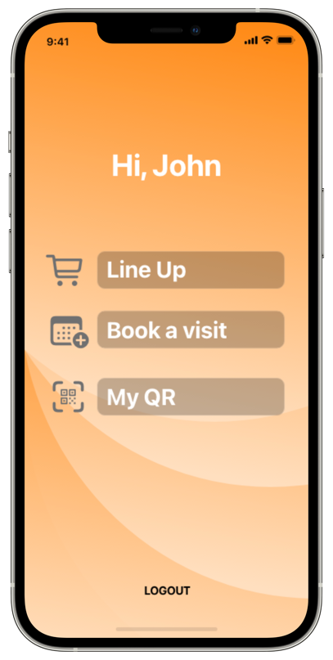

Figure 1

Figure 2

Figure 3

* **Customer Login Interface**

It is the initial interface. As shown in Figure 1, it allows Customers to log in by entering their credentials or to recover their password if they have forgotten it.

* **Customer Registration Interface**

Through the registration interface, shown in Figure 2, it is possible to create an account. In order to do this, Unregistered Users need to enter their name, email and a secure password in the appropriate fields. They must also accept the Terms and Conditions and the Privacy Statement through the appropriate controls.

* **Customer Homepage Interface**

As shown in Figure 3, this interface allows Customers to access the three main services offered by CLup. They can access the functionality they are interested in by simply interacting with the buttons.

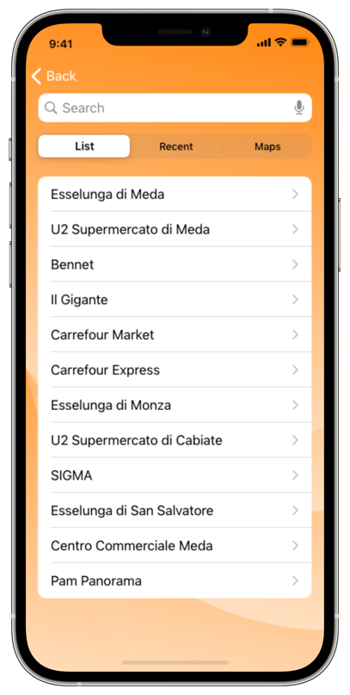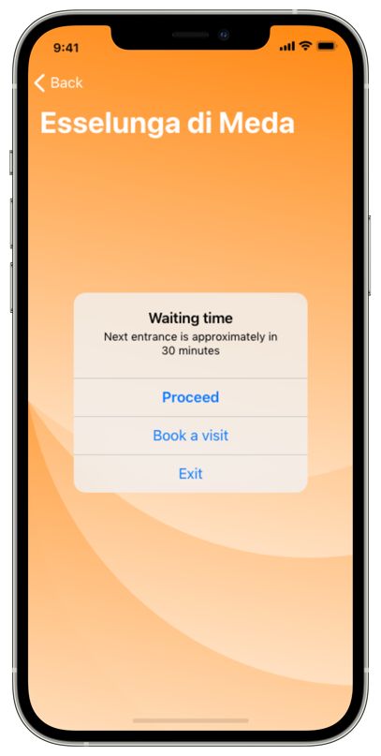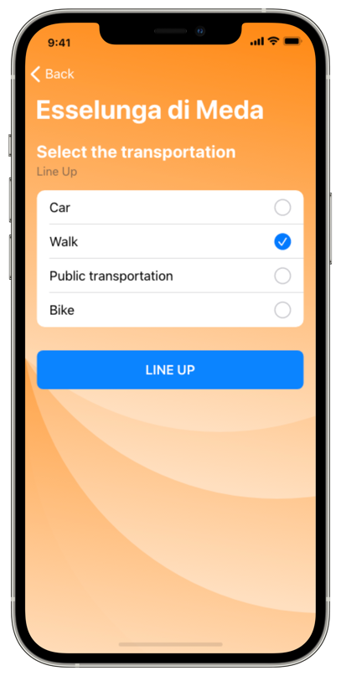

Figure 4

Figure 5

Figure 6

* **Customer Line Up Interface**

From this page, shown in Figure 4, Customers can use the “Line Up” Service. In particular, they can select a store directly from the list of the nearby ones or from the list of the recently visited ones. They can also use the map view or perform a simple search in order to find the supermarket they are looking for. Once found, Customers can view the estimated waiting time (Figure 5) and possibly proceed by indicating how they intend to reach the store (Figure 6). Once queued (Figure 7), the application will send them a notification when it is time to leave, as shown in Figure 8.

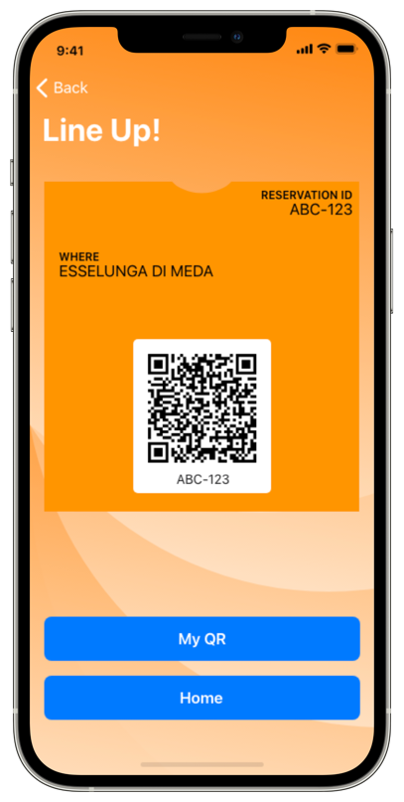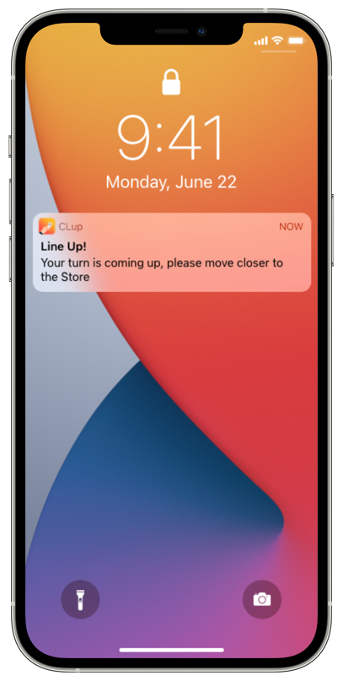

Figure 7

Figure 8

* **Guest Line Up Interface**

In front of the shop, Guests can access the “Line Up” Service by interacting with a PTD showing the interface of Figure 9. By simply pressing the “Line Up” button on the screen, a paper ticket is issued.

Figure 9

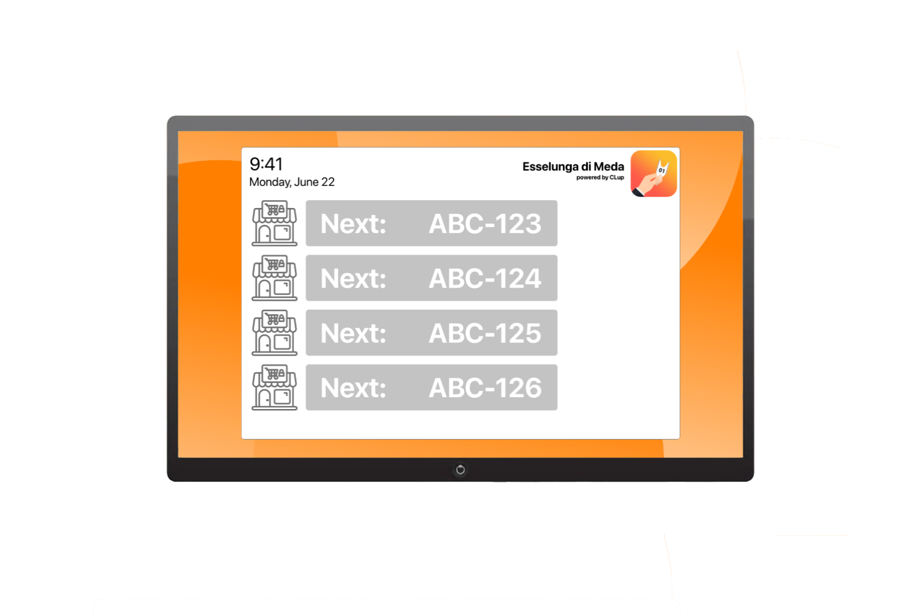

Figure 10

* **Next Up Interface**

In front of the entrance of the stores, Customers and Guests can view, through the interface shown in Figure 10, which codes are allowed to access.

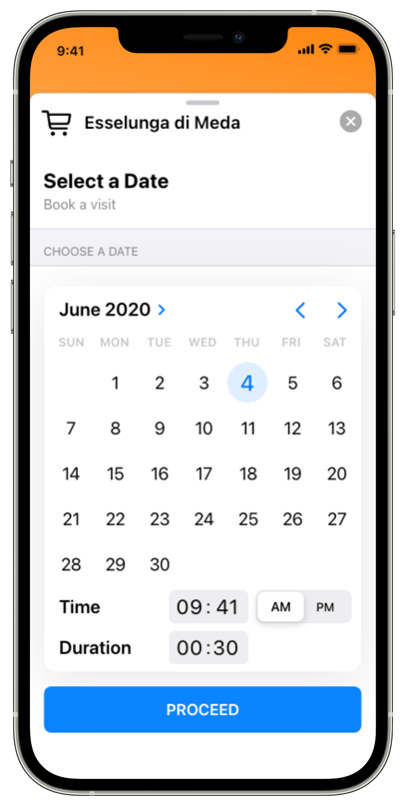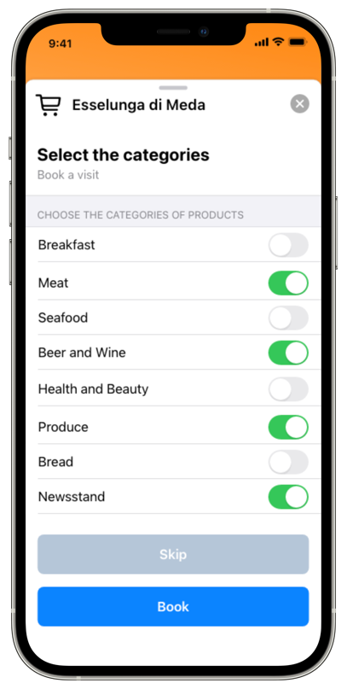

Figure 11

Figure 12

Figure 13

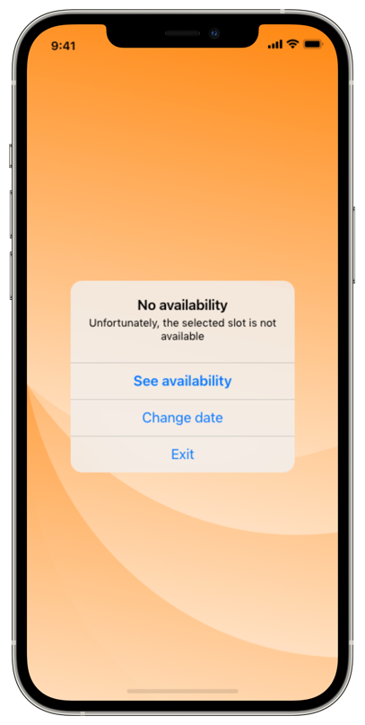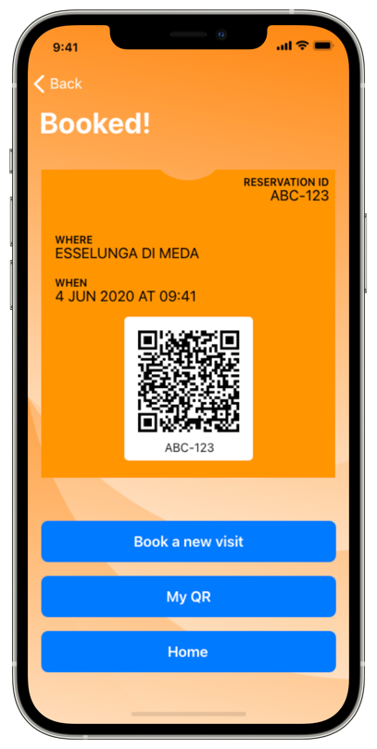

Figure 14

Figure 15

Figure 16

* **Visit Booking Interface**

From this page, shown in Figure 11, Customers can use the “Book a Visit” Service. In particular, they can select a store. Once selected, using the calendar view of Figure 12, they can also indicate the date, the time and the duration of the visit. Finally, they can select the categories using the various controls shown in Figure 13. In case there are no slots available (Figure 14), the application suggests other available slots of the selected store (Figure 15). The Customer has the opportunity to select one of the suggested or to find another Store for the preferred slot. At the end of the process the QR code and ReservationID are shown (Figure 16).

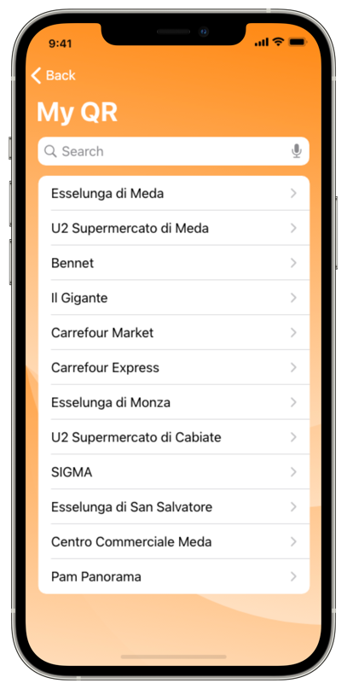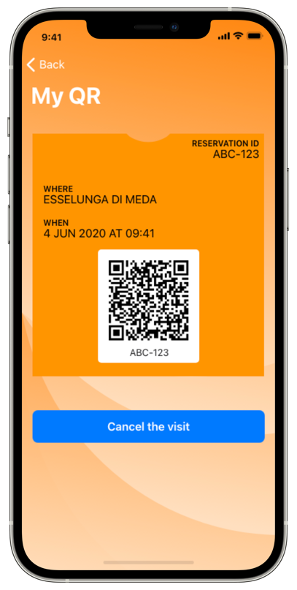

Figure 17

Figure 18

Figure 19

* **My QR Interface**

From this page, whose interface is illustrated in Figure 17, Customers can access all their electronic tickets, select one of them (Figure 18) and possibly cancel the reservations made (Figure 19).

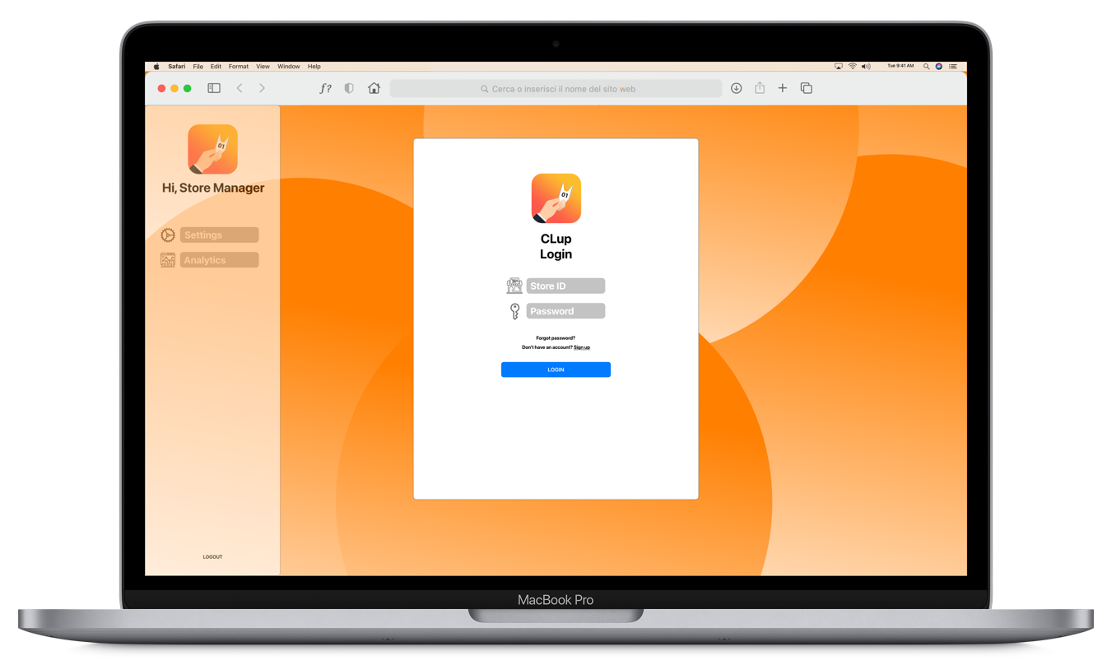

Figure 20

* **Store Manager Login Interface**

Store Managers can access CLup Services through the interface shown in Figure 20. They are asked to enter the Store ID and the password indicated during the registration. If they do not yet have an account, they can simply access the registration page via an appropriate button.

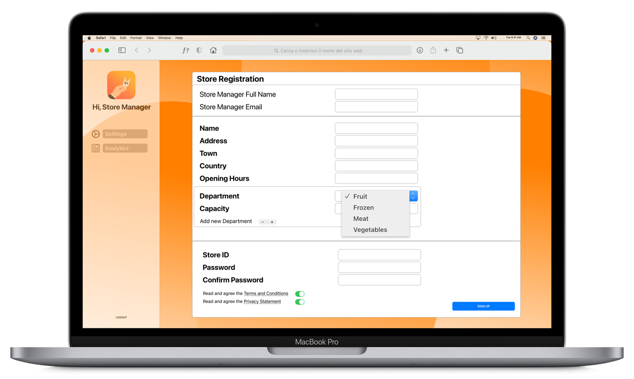

Figure 21

* **Store Manager Registration Interface**

Store Managers can register their supermarkets to CLup through the page shown in Figure 21. Through a simple form, they can enter all the required data. In particular, they can indicate the departments of their store, by choosing them through a simple drop-down menu, and the capacity of each of them.

Figure 22

* **Store Manager Homepage Interface**

As reported in Figure 22, the homepage shows to the Store Manager all the information about his supermarket. It also allows him to open the statistics page via a simple button. Moreover, he can access the controls to update supermarket information.

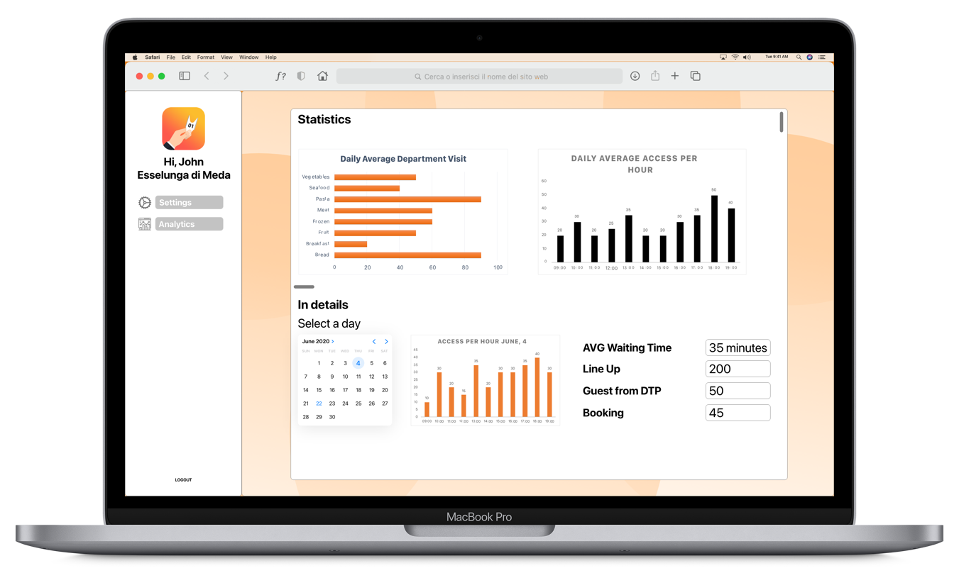

Figure 23

* **Statistics Interface**

From the statistics page, Store Managers can analyse bar graphs relating to the most visited departments of the store and to the number of accesses per hour. They can also access controls through which they can select the reference period for the statistics. As reported in Figure 23, the page then shows further information such as the average waiting time.

### Hardware Interfaces

In order to minimize contacts between people, the CLup System must necessarily be highly automated. For this reason, each registered store must have the following hardware devices:

* a *QR code reader* positioned in front of all the entrances and exits of the building,
* remotely controllable *sliding doors*,
* at least a device with a monitor to show the codes that can access the store,
* a *touch screen monitor* connected to a system capable of printing tickets for Guests.

Store Managers must also have a *computer* in order to join the service and analyse the store statistics.

Finally, Customers must have a *smartphone* equipped with GPS in order to use the CLup Application and all its functionalities.

### 3.1.3 Software Interfaces

The CLup System relies on various external services accessible via API. These services are:

* **Maps Service**: the CLup System relies on it for the computation of the ETA.
* **Sliding Door System**: the CLup System relies on it to control the sliding doors installed in the stores.
* **QR Code Reader System**: the CLup System relies on it for reading QR codes using the readers installed in the stores.
* **Ticket Printing System**: The CLup System relies on it to print paper tickets.

### 3.1.4 Communication Interfaces

The various devices connect to the CLup System via internet connection.

## 3.2 Functional Requirements

### 3.2.1 Use Case Diagrams

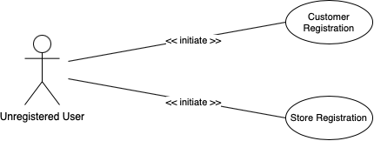

Use Case Diagram 1: Unregistered User

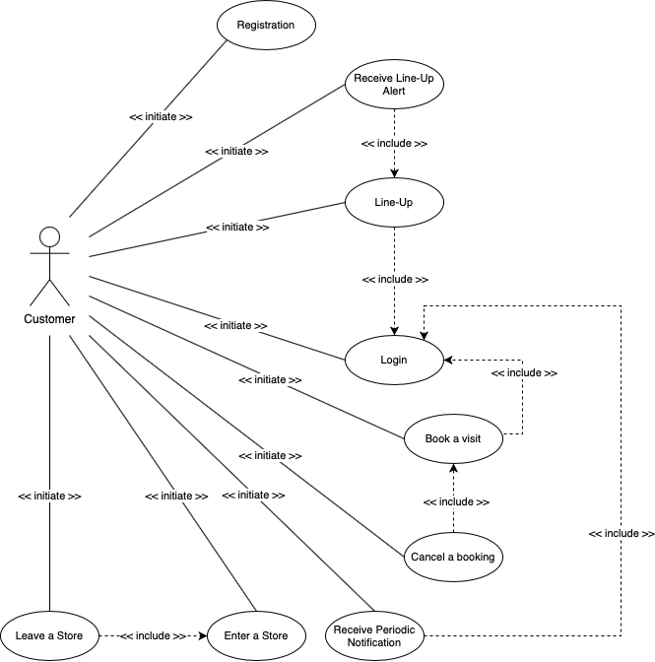

Use Case Diagram 2: Customer

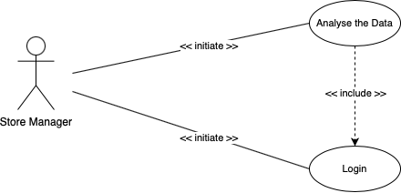

Use Case Diagram 3: Store Manager

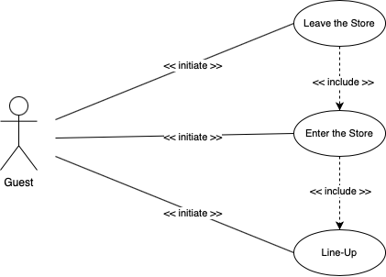

Use Case Diagram 4: Guest

### 3.2.2 Use Case Analysis

|  |  |
| --- | --- |
| **Name** | **[UC.1] Customer Registration** |
| **Actors** | Unregistered User |
| **Entry Conditions** | * Unregistered User wants to join CLup |
| **Events Flow** | 1. Unregistered User opens the Application entering in the account creation page 2. Unregistered User enters his full name in the appropriate fields 3. Unregistered User enters his email 4. Unregistered User enters a password 5. Unregistered User checks the “Accept Terms and Conditions” checkbox 6. Unregistered User checks the “Accept Privacy Statement” checkbox 7. Unregistered User presses the “Sign Up” button 8. The System saves the information |
| **Exit Conditions** | * Unregistered User successfully registered on CLup |
| **Exceptions** | * Inserted password does not comply with the minimum-security standards * Not all required fields are correctly filled in * “Accept Terms and Conditions” checkbox is not checked * “Accept Privacy Statement” checkbox is not checked   In these situations, the Application shows an error message |

|  |  |
| --- | --- |
| **Name** | **[UC.2] Customer Login** |
| **Actors** | Customer |
| **Entry Conditions** | * Customer is successfully registered to CLup |
| **Events Flow** | 1. Customer opens the Application entering in the login page 2. Customer enters his email in the appropriate field 3. Customer enters his password in the appropriate field 4. Customer presses the “Login” button 5. The System checks Customer’s credentials |
| **Exit Conditions** | * Customer successfully logged in |
| **Exceptions** | * Inserted email is not valid * Inserted password is not valid   In these situations, the Application shows an error message |

|  |  |
| --- | --- |
| **Name** | **[UC.3] Store Registration** |
| **Actors** | Unregistered User |
| **Entry Conditions** | * Unregistered User wants to register a store |
| **Events Flow** | 1. In the homepage, Unregistered User presses the “Store Registration” button entering in the account creation page 2. Unregistered User enters his full name in the appropriate fields 3. Unregistered User enters his email 4. Unregistered User enters the store name 5. Unregistered User enters the store address 6. Unregistered User indicates the opening hours of the store by filling in the appropriate fields 7. Unregistered User selects a department of the store from a drop-down menu and indicates its capacity. He repeats this step until he has indicated all the departments of the store 8. Unregistered User indicates a Store ID 9. Unregistered User indicates a password 10. Unregistered User checks the “Accept Terms and Conditions” checkbox 11. Unregistered User checks the “Accept Privacy Statement” checkbox 12. Unregistered User presses the “Sign Up” button 13. The System saves the information |
| **Exit Conditions** | * The store is successfully registered on CLup. |
| **Exceptions** | * Inserted password does not comply with the minimum-security standards * Inserted Store ID has already been taken * Not all required fields are correctly filled in * “Accept Terms and Conditions” checkbox is not checked * “Accept Privacy Statement” checkbox is not checked   In these situations, the Application shows an error message |

|  |  |
| --- | --- |
| **Name** | **[UC.4] Store Manager Login** |
| **Actors** | Store Manager |
| **Entry Conditions** | * Store Manager is successfully registered to CLup |
| **Events Flow** | 1. In the homepage, Store Manager enters his Store ID in the appropriate field 2. Store Manager enters his password in the appropriate field 3. Store Manager presses the “Login” button 4. The System checks Store Manager’s credentials |
| **Exit Conditions** | * Store Manager successfully logged in |
| **Exceptions** | * Inserted Store ID is not valid * Inserted password is not valid   In these situations, the Application shows an error message |

|  |  |
| --- | --- |
| **Name** | **[UC.5] Customer Line Up** |
| **Actors** | Customer |
| **Entry Conditions** | * Customer successfully logged into CLup * Customer wants to Line Up at a store |
| **Events Flow** | 1. In the homepage, Customer presses the “Line Up” button 2. Customer selects a store from the list of the registered ones, possibly entering a part of its name or using the map view 3. Customer views the estimated waiting time computed by the System 4. Customer decides to proceed and presses the “Proceed” button 5. Customer selects the transportation he will use to reach the store 6. Customer presses the “Line Up” button 7. The System displays the electronic ticket containing the QR code needed to enter the store and the associated Reservation ID |
| **Exit Conditions** | * Customer is correctly queued at the chosen supermarket |
| **Exceptions** | * Customer considers the waiting time too high and decides not to queue   In this situation, Customer simply closes the Application |

|  |  |
| --- | --- |
| **Name** | **[UC.6] Customer receives a Line Up alert** |
| **Actors** | Customer |
| **Entry Conditions** | * Customer successfully logged into CLup * Customer has successfully lined-up * The Reservation ID associated to the Customer is close to being called |
| **Events Flow** | 1. Customer receives on his smartphone a notification from the System informing him that it’s time to leave 2. Customer reads the notification 3. Customer is about to leave the place in which he is |
| **Exit Conditions** | * Customer is headed to the store |

|  |  |
| --- | --- |
| **Name** | **[UC.7] Guest Line Up** |
| **Actors** | Guest |
| **Entry Conditions** | * Guest wants to line up at a store * Guest arrived at a store |
| **Events Flow** | 1. Guest reaches the PTD of the store 2. Guest views the estimated waiting time computed by the System on the PTD 3. Guest decides to proceed through the process and presses the “Line Up” button 4. The PTD emits a paper ticket containing the QR code needed to enter the store and the associated Reservation ID |
| **Exit Conditions** | * Guest received the paper ticket * Guest is correctly queued at the chosen supermarket |
| **Exceptions** | * Guest considers the waiting time too high and decides not to queue   In this situation, Guest leaves the store |

|  |  |
| --- | --- |
| **Name** | **[UC.8] Customer books a visit** |
| **Actors** | Customer |
| **Entry Conditions** | * Customer successfully logged into CLup * Customer wants to book a visit to a store |
| **Events Flow** | 1. In the homepage, Customer presses the “Book a Visit” button 2. Customer selects a store from the list of the registered ones, possibly entering a part of its name or using the map view 3. Customer selects the date and the time he would like to go to the store 4. Customer indicates the expected duration of the visit 5. Customer presses the “Next” button 6. Customer selects the categories of products he will buy from a checklist 7. Customer presses the button “Book” 8. The System saves the booking information and displays the electronic ticket containing the QR code needed to enter the store and the associated Reservation ID |
| **Exit Conditions** | * Customer successfully booked the chosen slot |
| **Exceptions** | * The desired time/date is not available   In this situation, the Application will suggest him other time/date slots or other supermarkets available at the desired time/date   * Customer leaves the field relating to the expected duration blank * Customer does not select any product category   In this situation, the process proceeds without problems because the fields are optional |

|  |  |
| --- | --- |
| **Name** | **[UC.9] Customer cancels a booking** |
| **Actors** | Customer |
| **Entry Conditions** | * Customer successfully logged into CLup * Customer successfully booked a visit to a store |
| **Events Flow** | 1. In the homepage, Customer presses the “My QR” button 2. Customer selects the reservation he wants to cancel from the list containing all his reservations 3. Customer presses the “Cancel” button 4. The System cancels the reservation |
| **Exit Conditions** | * The visit is successfully cancelled |

|  |  |
| --- | --- |
| **Name** | **[UC.10] Customer enters a store** |
| **Actors** | Customer |
| **Entry Conditions** | * Customer has successfully lined-up from the Application or booked a visit * The Reservation ID of the Customer appears on the store’s display |
| **Events Flow** | 1. Customer reaches the store entrance 2. Customer opens the CLup Application on his smartphone 3. Customer retrieves the electronic ticket from the “My QR” view 4. Customer exhibits the QR code to the scanner 5. The System checks the corresponding ticket information 6. The automatic sliding doors open 7. Customer enters the store |
| **Exit Conditions** | * Customer has successfully entered the store |
| **Exceptions** | * Customer forgets the smartphone at home * The battery of the Customer’s smartphone is dead * Customer is 15 minutes late with respect to the scheduled entry time, therefore the ticket is no longer valid * It’s not the Customer’s turn yet or the ticket is not valid   In these situations, Customer lines up from the PTD of the store as a Guest or comes back home |

|  |  |
| --- | --- |
| **Name** | **[UC.11] Guest enters a store** |
| **Actors** | Guest |
| **Entry Conditions** | * Guest has successfully lined-up from the PTD * The Reservation ID of the Guest appears on the store’s display |
| **Events Flow** | 1. Guest reaches the store entrance 2. Guest retrieves the paper ticket 3. Guest exhibits the QR code to the scanner 4. The System checks the corresponding ticket information 5. The automatic sliding doors open 6. Guest enters the store |
| **Exit Conditions** | * Guest has successfully entered the store |
| **Exceptions** | * Guest has lost his paper ticket * Guest is 15 minutes late with respect to the scheduled entry time, therefore the ticket is no longer valid * It’s not the Guest’s turn yet or the ticket is not valid   In this situation, Guest requests another ticket from the PTD or comes back home |

|  |  |
| --- | --- |
| **Name** | **[UC.12] Customer** **leaves a store** |
| **Actors** | Customer |
| **Entry Conditions** | * Customer entered the store * Customer wants to leave the store |
| **Events Flow** | 1. Customer reaches the store exit 2. Customer opens the CLup Application on his smartphone 3. Customer retrieves the electronic ticket from the “My QR” view 4. Customer exhibits the QR code to the scanner 5. The automatic sliding doors open 6. Customer leaves the store |
| **Exit Conditions** | * Customer has successfully left the shop |
| **Exceptions** | * The battery of the Customer’s smartphone is dead * Customer exhibits an incorrect code   In this situation, Customer asks for help to the shop staff |

|  |  |
| --- | --- |
| **Name** | **[UC.13] Guest leaves a store** |
| **Actors** | Guest |
| **Entry Conditions** | * Guest entered the store * Guest wants to leave the store |
| **Events Flow** | 1. Guest reaches the store exit 2. Guest retrieves the paper ticket 3. Guest exhibits the QR code to the scanner 4. The automatic sliding doors open 5. Guest leaves the store |
| **Exit Conditions** | * Guest has successfully left the shop |
| **Exceptions** | * Guest has lost his paper ticket * Guest exhibits an incorrect code   In this situation, Guest asks for help to the shop staff |

|  |  |
| --- | --- |
| **Name** | **[UC.14] Store Manager analyses the data** |
| **Actors** | Store Manager |
| **Entry Conditions** | * Store Manager successfully logged into CLup * Store Manager wants to analyse the data |
| **Events Flow** | 1. In the homepage, Store Manager presses the “Check access data” button entering in the statistics page 2. Store Manager selects the month whose statistics he wants to analyse by choosing it in a drop-down menu 3. The System displays bar graphs related to the most visited departments of the store and to the number of accesses per hour |
| **Exit Conditions** | * The graphs are shown and can be analysed by the Store Manager |

|  |  |
| --- | --- |
| **Name** | **[UC.15] Customer** **receives a periodic notification** |
| **Actors** | Customer |
| **Entry Conditions** | * Customer successfully logged into CLup * The System detects a free slot that may be of interest to the Customer |
| **Events Flow** | 1. Customer receives a notification from the System informing him of the availability of a slot in the day/time range he prefers 2. Customer reads the details of the suggestion |
| **Exit Conditions** | * Customer is aware of the presence of some available slots |

### 3.2.3 Sequence Diagrams

This section provides a high-level representation of the interaction processes between the various actors and the System. They constitute a visual representation of some of the previously described use cases.

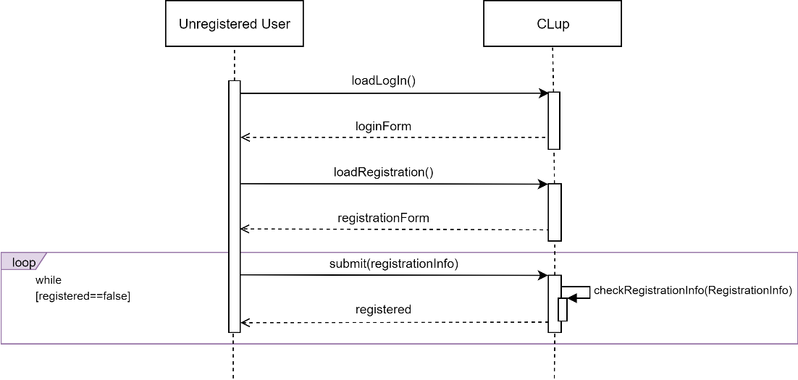

Sequence Diagram 1: Customer/Store Manager Registration

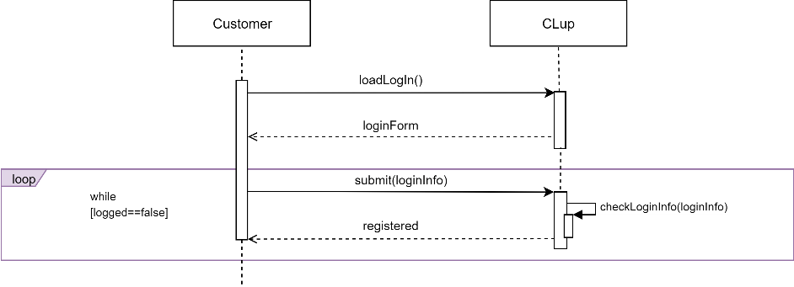

Sequence Diagram 2: Customer Login

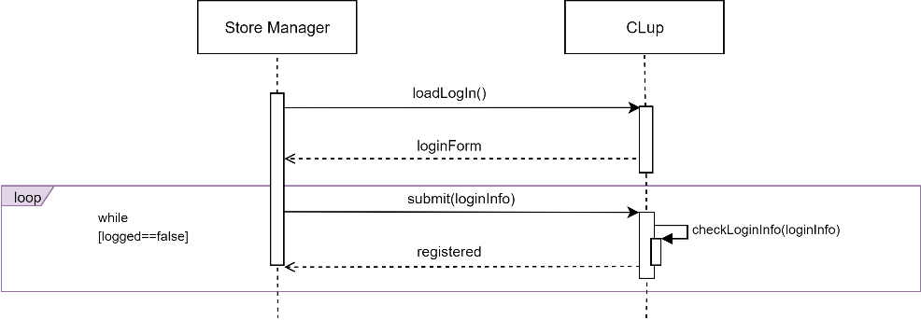

Sequence Diagram 1: Store Manager Login

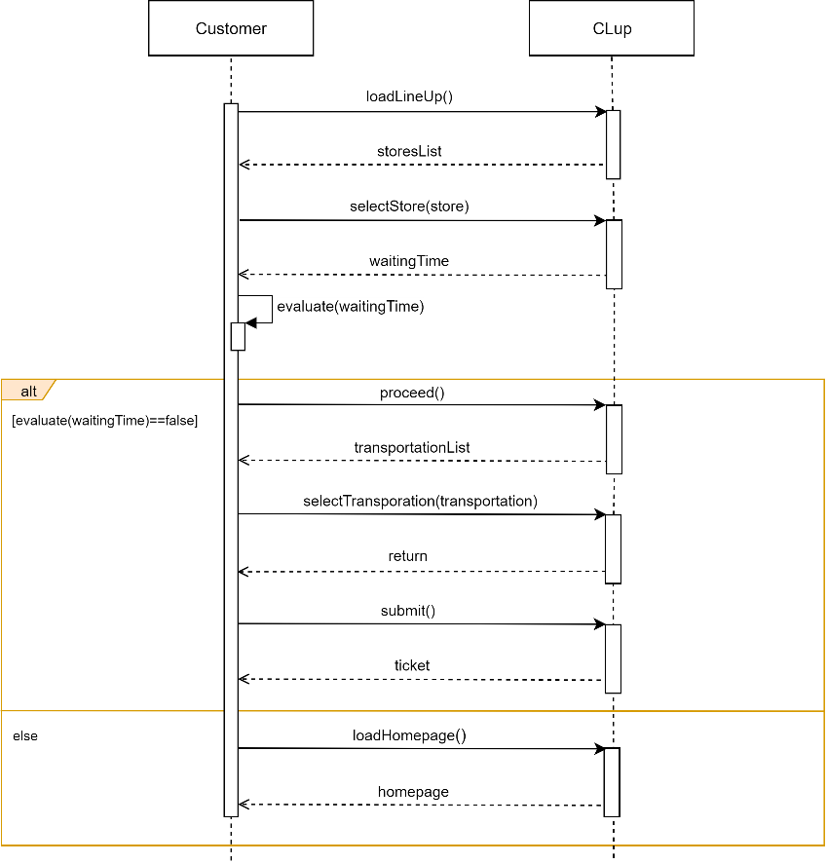

Sequence Diagram 2: Customer Line-Up

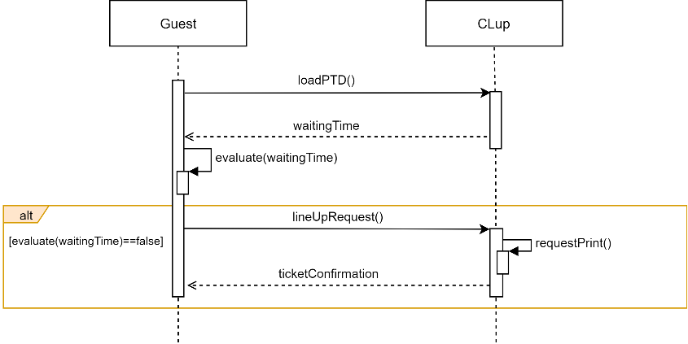

Sequence Diagram 3: Guest Line-Up

Sequence Diagram 4: Customer Book a Visit

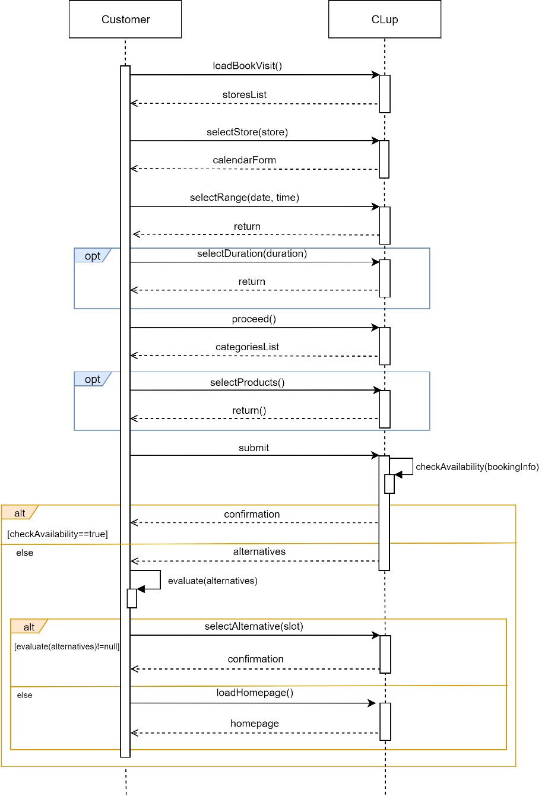

Sequence Diagram 9: Guest Enters/Leaves a Store

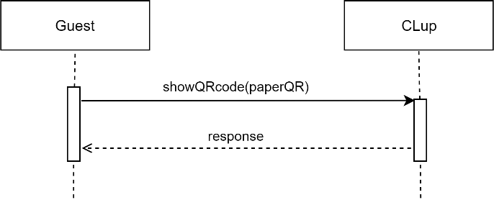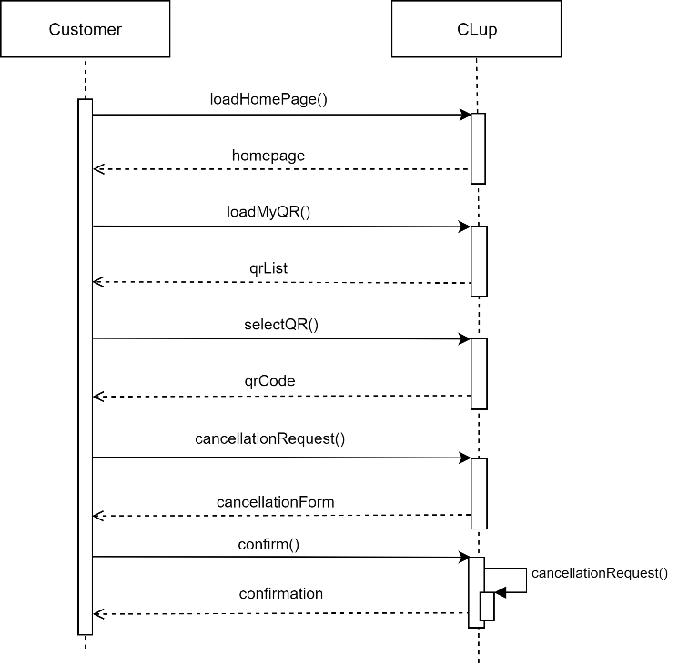

Sequence Diagram 5: Customer Cancel a Booking

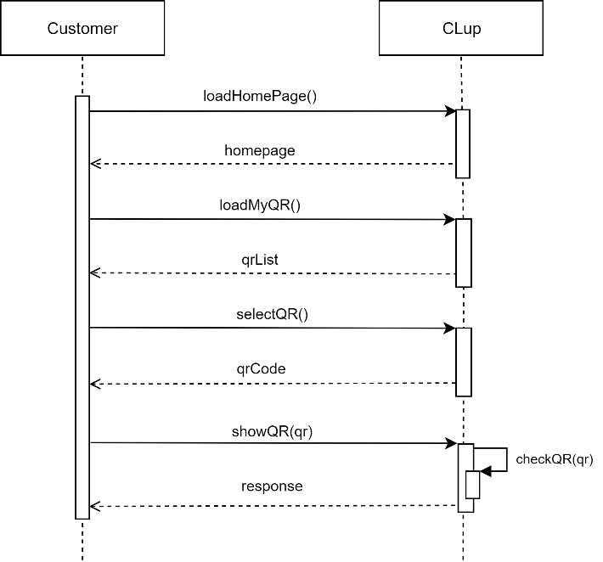

Sequence Diagram 7: Customer Enters/Leaves a Store

Sequence Diagram 6: Store Manager Analyses the Data

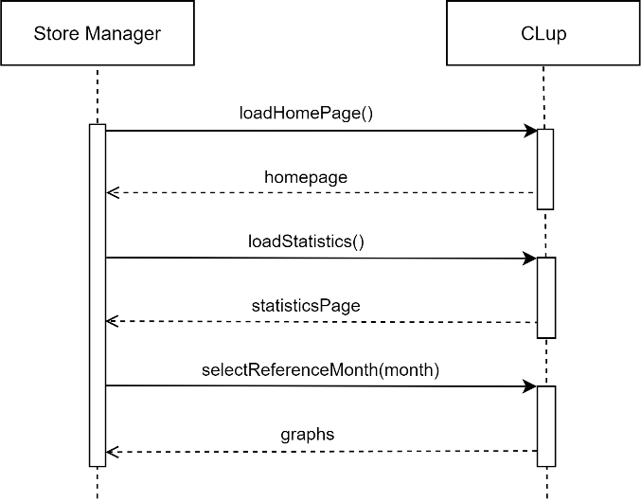

### Requirements

This section lists all the requirements that the CLup System must meet in order to achieve the set goals. A detailed mapping between the two will be provided in section 3.2.5.

1. The System must allow Customer to register to CLup by filling in a form containing a set of fields
   1. Customer must be able to indicate his full name
   2. Customer must be able to indicate an email
   3. Customer must be able to indicate a password
   4. Customer must be able to read and accept the Terms and Conditions and the Privacy Statement
2. The System must store the data relating to the Customers
3. The System must allow Customer to login to CLup by entering his email and password
4. The System must allow Store Manager to register to CLup by filling in a form containing a set of fields
   1. Store Manager must be able to indicate his full name
   2. Store Manager must be able to indicate an email
   3. Store Manager must be able to indicate the name of his store
   4. Store Manager must be able to indicate a Store ID for his store
   5. Store Manager must be able to indicate the address of his store
   6. Store Manager must be able to indicate the opening hours of his store
   7. Store Manager must be able to indicate all the departments of his shop and an indicative capacity for each of them
   8. Store Manager must be able to read and accept the Terms and Conditions and the Privacy Statement
5. The System must store the data relating to the supermarkets
6. The System must allow Store Manager to login to CLup by entering his Store ID and password
7. The System must ask the Customer for permission to access his local position
8. The System must ask the Customer for permission to send him notifications
9. The System must be able to generate electronic tickets
10. The System must be able to emit paper tickets
11. The System must be able to associate a unique QR code to each issued ticket
12. The System must be able to associate a unique Reservation ID to each issued ticket
13. The System must store the data relating to the queues of the shops
14. The System must be able to read a QR code at the entrance of a store
15. The System must be able to read a QR code at the exit of a store
16. The System must be able to control the sliding doors of a store
17. The System must be able to show which Reservation IDs can access a store at any given time
18. The System must be able to inhibit or grant access to a store for issued tickets
19. The System must allow Guest to require a paper ticket through the PTD
20. The System must allow Guest to view the estimated waiting time from the PTD
21. The System must keep stored historical data relating to the time of access and exit from the store
22. The System must allow Customer to require an electronic ticket through the Application
    1. Customer must be able to indicate a supported store
    2. Customer must be able to indicate the transportation he will use to reach the store
23. The System must periodically estimate the waiting time
24. The System must allow Customer to visualise the estimation of the waiting time from the Application
25. The System must periodically check the traffic conditions
26. The System must be able to send a notification to Customer
27. The System must allow Customer to send a request to book a visit by filling in a form containing a set of fields
    1. Customer must be able to indicate a supported store
    2. Customer must be able to indicate a booking date
    3. Customer must be able to indicate the expected duration of the visit
    4. Customer must be able to indicate the categories of products he intends to buy
28. The System must store the data relating to the booking of visits
29. The System must be able to compute the average time of visit for long-term Customers
30. The System must allow Customer to visualise his valid electronic tickets
31. The System must periodically compute the statistics relating to the stored access data
32. Store Manager must be able to visualise the statistics relating to the access data
33. Store Manager must be able to change the departments and the capacity of each of them

### Traceability Matrix

This section provides a summary of the mapping between the goals and the requirements that guarantee their achievement under some domain assumptions.

|  |  |  |
| --- | --- | --- |
| **Goals** | **Domain Assumptions** | **Requirements** |
| **[G.1]** | [D.1], [D.2], [D.3], [D.8], [D.11], [D.12] | [R.1], [R.2], [R.3], [R.4], [R.5], [R.9], [R.10], [R.11], [R.12], [R.13], [R.14], [R.15] [R.16], [R.18], [R.19], [R.21], [R.22], [R.28], [R.29], [R.33] |
| **[G.2]** | [D.3], [D.4], [D.7] | [R.1], [R.2], [R.3], [R.4], [R.5], [R.9], [R.11], [R.12], [R.13], [R.21], [R.22], [R.23], [R.24], [R.28], [R.29], [R.30] |
| **[G.3]** | [D.3], [D.6] | [R.4], [R.5], [R.10], [R.11], [R.12], [R.13], [R.17], [R.19], [R.20], [R.21], [R.23], [R.28], [R.29] |
| **[G.4]** | [D.1], [D.2], [D.8], [D.11], [D.12] | [R.4], [R.5], [R.6], [R.13], [R.14], [R.15], [R.21], [R.28], [R.31], [R.32] |
| **[G.5]** | [D.3], [D.4], [D.5], [D.7], [D.9], [D.10] | [R.1], [R.2], [R.3], [R.4], [R.5], [R.7], [R.8], [R.12], [R.13], [R.14], [R.15], [R.21], [R.23], [R.25], [R.26], [R.29] |
| **[G.6]** | [D.3], [D.4], [D.7] | [R.1], [R.2], [R.3], [R.4], [R.5], [R.9], [R.11], [R.12], [R.13], [R.21], [R.27], [R.28], [R.29], [R.30] |
| **[G.7]** | [D.3], [D.4], [D.7] | [R.1], [R.2], [R.3], [R.4], [R.5], [R.13], [R.21], [R.28], [R.29] |
| **[G.8]** | [D.3], [D.4], [D.5], [D.7], [D.9] | [R.1], [R.2], [R.3], [R.4], [R.5], [R.7], [R.13], [R.21], [R.28], [R.29] |
| **[G.9]** | [D.3], [D.4], [D.7] | [R.1], [R.2], [R.3], [R.4], [R.5], [R.8], [R.12], [R.21], [R.26], [R.28], [R.29] |

|  |  |
| --- | --- |
| **[G.1]** | Allows Store Managers to regulate the influx of the people in their store |
| **[D.1]** | No customer, be it a Customer or a Guest, can enter a store without having shown a QR code at the entrance |
| **[D.2]** | No customer, be it a Customer or a Guest, can leave a store without having shown a QR code at the exit |
| **[D.3]** | Data given by Store Managers are assumed to be correct |
| **[D.8]** | Store Manager owns a working device which has access to Internet connection |
| **[D.11]** | The external service used by the System to control the sliding doors is assumed to work properly |
| **[D.12]** | The external service used by the System to read the QR codes is assumed to work properly |
| **[R.1]** | The System must allow Customer to register to CLup by filling in a form containing a set of fields |
| **[R.2]** | The System must store the data relating to the Customers |
| **[R.3]** | The System must allow Customer to login to CLup by entering his email and password |
| **[R.4]** | The System must allow Store Manager to register to CLup by filling in a form containing a set of fields |
| **[R.5]** | The System must store the data relating to the supermarkets |
| **[R.9]** | The System must be able to generate electronic tickets |
| **[R.10]** | The System must be able to emit paper tickets |
| **[R.11]** | The System must be able to associate a unique QR code to each issued ticket |
| **[R.12]** | The System must be able to associate a unique Reservation ID to each issued ticket |
| **[R.13]** | The System must store the data relating to the queues of the shops |
| **[R.14]** | The System must be able to read a QR code at the entrance of a store |
| **[R.15]** | The System must be able to read a QR code at the exit of a store |
| **[R.16]** | The System must be able to control the sliding doors of a store |
| **[R.18]** | The System must be able to inhibit or grant access to a store for issued tickets |
| **[R.19]** | The System must allow Guest to require a paper ticket through the PTD |
| **[R.21]** | The System must keep stored historical data relating to the time of access and exit from the store |
| **[R.22]** | The System must allow Customer to require an electronic ticket through the Application |
| **[R.28]** | The System must store the data relating to the booking of visits |
| **[R.29]** | The System must be able to compute the average time of visit for long-term Customers |
| **[R.33]** | Store Manager must be able to change the departments and the capacity of each of them |

|  |  |
| --- | --- |
| **[G.2]** | Allows Customers to line up from their home |
| **[D.3]** | Data given by Store Managers are assumed to be correct |
| **[D.4]** | Data given by Customers are assumed to be correct |
| **[D.7]** | Customer owns a working smartphone which has access to Internet connection |
| **[R.1]** | The System must allow Customer to register to CLup by filling in a form containing a set of fields |
| **[R.2]** | The System must store the data relating to the Customers |
| **[R.3]** | The System must allow Customer to login to CLup by entering his email and password |
| **[R.4]** | The System must allow Store Manager to register to CLup by filling in a form containing a set of fields |
| **[R.5]** | The System must store the data relating to the supermarkets |
| **[R.9]** | The System must be able to generate electronic tickets |
| **[R.11]** | The System must be able to associate a unique QR code to each issued ticket |
| **[R.12]** | The System must be able to associate a unique Reservation ID to each issued ticket |
| **[R.13]** | The System must store the data relating to the queues of the shops |
| **[R.21]** | The System must keep stored historical data relating to the time of access and exit from the store |
| **[R.22]** | The System must allow Customer to require an electronic ticket through the Application |
| **[R.23]** | The System must periodically estimate the waiting time |
| **[R.24]** | The System must allow Customer to visualise the estimation of the waiting time from the Application |
| **[R.28]** | The System must store the data relating to the booking of visits |
| **[R.29]** | The System must be able to compute the average time of visit for long-term Customers |
| **[R.30]** | The System must allow Customer to visualise his valid electronic tickets |

|  |  |
| --- | --- |
| **[G.3]** | Allows Guests to line up physically from a store |
| **[D.3]** | Data given by Store Managers are assumed to be correct |
| **[D.6]** | The printer connected to the PTD is assumed to work properly |
| **[R.4]** | The System must allow Store Manager to register to CLup by filling in a form containing a set of fields |
| **[R.5]** | The System must store the data relating to the supermarkets |
| **[R.10]** | The System must be able to emit paper tickets |
| **[R.11]** | The System must be able to associate a unique QR code to each issued ticket |
| **[R.12]** | The System must be able to associate a unique Reservation ID to each issued ticket |
| **[R.13]** | The System must store the data relating to the queues of the shops |
| **[R.17]** | The System must be able to show which Reservation IDs can access a store at any given time |
| **[R.19]** | The System must allow Guest to require a paper ticket through the PTD |
| **[R.20]** | The System must allow Guest to view the estimated waiting time from the PTD |
| **[R.21]** | The System must keep stored historical data relating to the time of access and exit from the store |
| **[R.23]** | The System must periodically estimate the waiting time |
| **[R.28]** | The System must store the data relating to the booking of visits |
| **[R.29]** | The System must be able to compute the average time of visit for long-term Customers |

|  |  |
| --- | --- |
| **[G.4]** | Allows Store Managers to keep access data under control |
| **[D.1]** | No customer, be it a Customer or a Guest, can enter a store without having shown a QR code at the entrance |
| **[D.2]** | No customer, be it a Customer or a Guest, can leave a store without having shown a QR code at the exit |
| **[D.8]** | Store Manager owns a working device which has access to Internet connection |
| **[D.11]** | The external service used by the System to control the sliding doors is assumed to work properly |
| **[D.12]** | The external service used by the System to read the QR codes is assumed to work properly |
| **[R.4]** | The System must allow Store Manager to register to CLup by filling in a form containing a set of fields |
| **[R.5]** | The System must store the data relating to the supermarkets |
| **[R.6]** | The System must allow Store Manager to login to CLup by entering his Store ID and password |
| **[R.13]** | The System must store the data relating to the queues of the shops |
| **[R.14]** | The System must be able to read a QR code at the entrance of a store |
| **[R.15]** | The System must be able to read a QR code at the exit of a store |
| **[R.21]** | The System must keep stored historical data relating to the time of access and exit from the store |
| **[R.28]** | The System must store the data relating to the booking of visits |
| **[R.31]** | The System must periodically compute the statistics relating to the stored access data |
| **[R.32]** | Store Manager must be able to visualise the statistics relating to the access data |

|  |  |
| --- | --- |
| **[G.5]** | Allows Customers to be notified when their number is close to being called, considering the time to get to the shop |
| **[D.3]** | Data given by Store Managers are assumed to be correct |
| **[D.4]** | Data given by Customers are assumed to be correct |
| **[D.5]** | The GPS is assumed to be accurate |
| **[D.7]** | Customer owns a working smartphone which has access to Internet connection |
| **[D.9]** | Customer owns a working smartphone which has a working GPS antenna |
| **[D.10]** | The external service used by the System to estimate the time it will take for the Customer to reach the store is supposed to be accurate |
| **[R.1]** | The System must allow Customer to register to CLup by filling in a form containing a set of fields |
| **[R.2]** | The System must store the data relating to the Customers |
| **[R.3]** | The System must allow Customer to login to CLup by entering his email and password |
| **[R.4]** | The System must allow Store Manager to register to CLup by filling in a form containing a set of fields |
| **[R.5]** | The System must store the data relating to the supermarkets |
| **[R.7]** | The System must ask the Customer for permission to access his local position |
| **[R.8]** | The System must ask the Customer for permission to send him notifications |
| **[R.12]** | The System must be able to associate a unique Reservation ID to each issued ticket |
| **[R.13]** | The System must store the data relating to the queues of the shops |
| **[R.14]** | The System must be able to read a QR code at the entrance of a store |
| **[R.15]** | The System must be able to read a QR code at the exit of a store |
| **[R.21]** | The System must keep stored historical data relating to the time of access and exit from the store |
| **[R.23]** | The System must periodically estimate the waiting time |
| **[R.25]** | The System must periodically check the traffic conditions |
| **[R.26]** | The System must be able to send a notification to Customer |
| **[R.29]** | The System must be able to compute the average time of visit for long-term Customers |

|  |  |
| --- | --- |
| **[G.6]** | Allows Customers to book a visit to a specific store in a specific date |
| **[D.3]** | Data given by Store Managers are assumed to be correct |
| **[D.4]** | Data given by Customers are assumed to be correct |
| **[D.7]** | Customer owns a working smartphone which has access to Internet connection |
| **[R.1]** | The System must allow Customer to register to CLup by filling in a form containing a set of fields |
| **[R.2]** | The System must store the data relating to the Customers |
| **[R.3]** | The System must allow Customer to login to CLup by entering his email and password |
| **[R.4]** | The System must allow Store Manager to register to CLup by filling in a form containing a set of fields |
| **[R.5]** | The System must store the data relating to the supermarkets |
| **[R.9]** | The System must be able to generate electronic tickets |
| **[R.11]** | The System must be able to associate a unique QR code to each issued ticket |
| **[R.12]** | The System must be able to associate a unique Reservation ID to each issued ticket |
| **[R.13]** | The System must store the data relating to the queues of the shops |
| **[R.21]** | The System must keep stored historical data relating to the time of access and exit from the store |
| **[R.27]** | The System must allow Customer to send a request to book a visit by filling in a form containing a set of fields |
| **[R.28]** | The System must store the data relating to the booking of visits |
| **[R.29]** | The System must be able to compute the average time of visit for long-term Customers |
| **[R.30]** | The System must allow Customer to visualise his valid electronic tickets |

|  |  |
| --- | --- |
| **[G.7]** | Suggests Customers alternative slots for visiting a specific store |
| **[D.3]** | Data given by Store Managers are assumed to be correct |
| **[D.4]** | Data given by Customers are assumed to be correct |
| **[D.7]** | Customer owns a working smartphone which has access to Internet connection |
| **[R.1]** | The System must allow Customer to register to CLup by filling in a form containing a set of fields |
| **[R.2]** | The System must store the data relating to the Customers |
| **[R.3]** | The System must allow Customer to login to CLup by entering his email and password |
| **[R.4]** | The System must allow Store Manager to register to CLup by filling in a form containing a set of fields |
| **[R.5]** | The System must store the data relating to the supermarkets |
| **[R.13]** | The System must store the data relating to the queues of the shops |
| **[R.21]** | The System must keep stored historical data relating to the time of access and exit from the store |
| **[R.28]** | The System must store the data relating to the booking of visits |
| **[R.29]** | The System must be able to compute the average time of visit for long-term Customers |

|  |  |
| --- | --- |
| **[G.8]** | Suggests Customers similar stores if the preferred one does not have slots available for booking in the near future |
| **[D.3]** | Data given by Store Managers are assumed to be correct |
| **[D.4]** | Data given by Customers are assumed to be correct |
| **[D.5]** | The GPS is assumed to be accurate |
| **[D.7]** | Customer owns a working smartphone which has access to Internet connection |
| **[D.9]** | Customer owns a working smartphone which has a working GPS antenna |
| **[R.1]** | The System must allow Customer to register to CLup by filling in a form containing a set of fields |
| **[R.2]** | The System must store the data relating to the Customers |
| **[R.3]** | The System must allow Customer to login to CLup by entering his email and password |
| **[R.4]** | The System must allow Store Manager to register to CLup by filling in a form containing a set of fields |
| **[R.5]** | The System must store the data relating to the supermarkets |
| **[R.7]** | The System must ask the Customer for permission to access his local position |
| **[R.13]** | The System must store the data relating to the queues of the shops |
| **[R.21]** | The System must keep stored historical data relating to the time of access and exit from the store |
| **[R.28]** | The System must store the data relating to the booking of visits |
| **[R.29]** | The System must be able to compute the average time of visit for long-term Customers |

|  |  |
| --- | --- |
| **[G.9]** | Provides Customers with periodic notifications about available slots in the day/time range they usually shop |
| **[D.3]** | Data given by Store Managers are assumed to be correct |
| **[D.4]** | Data given by Customers are assumed to be correct |
| **[D.7]** | Customer owns a working smartphone which has access to Internet connection |
| **[R.1]** | The System must allow Customer to register to CLup by filling in a form containing a set of fields |
| **[R.2]** | The System must store the data relating to the Customers |
| **[R.3]** | The System must allow Customer to login to CLup by entering his email and password |
| **[R.4]** | The System must allow Store Manager to register to CLup by filling in a form containing a set of fields |
| **[R.5]** | The System must store the data relating to the supermarkets |
| **[R.8]** | The System must ask the Customer for permission to send him notifications |
| **[R.12]** | The System must be able to associate a unique Reservation ID to each issued ticket |
| **[R.21]** | The System must keep stored historical data relating to the time of access and exit from the store |
| **[R.26]** | The System must be able to send a notification to Customer |
| **[R.28]** | The System must store the data relating to the booking of visits |
| **[R.29]** | The System must be able to compute the average time of visit for long-term Customers |

## 3.5 Performance Requirements

The System does not have specific requirements on performances such as response time.

## 3.4 Design Constraints

### Standard compliance

* The geo-location coordinates must be encoded as longitude and latitude degrees.
* Since the software is meant to be used in Italy, dates and times must always be expressed with respect to the *ISO 8601 standard.*

### 3.4.2 Hardware limitations

* Customers’ smartphones must be able to exchange data via the internet and must have a GPS antenna.
* The devices used by Store Managers must be able to exchange data over the internet via a web browser.
* The devices used to host the PTD software must have a touchscreen and must be able to exchange data via the internet.

### 3.4.3 Any other constraint

* The System should be very intuitive and simple to use, as the range of users includes all demographics.

## 3.5 Software System Attributes

### 3.5.1 Reliability

The System must be robust and fault tolerant.

### 3.5.2 Availability

The System should be up for 99% of the time. That means that the average time between the occurrence of a fault and service recovery (MTTR or downtime) should be not greater than 3.65 days per year.

### 3.5.3 Security

To ensure a secure system, CLup uses only encrypted communication protocols. In addition, the data stored in the System has to be encrypted and also the passwords have to be hashed before being stored. Finally, the System should be protected against intrusion from agents that are not authorized to access it.

### 3.5.4 Maintainability

The System should be organized in modules and be well documented, in order to make maintenance, upgrades and integration of new features easy.

### 3.5.5 Portability

The software must run on different platforms including Windows and macOS. In addition, it should be available for iOS and Android devices.

**Chapter 4**

# 4 Formal Analysis using Alloy

In this chapter we present how the critical components of the System have been modelled using Alloy, a formal language used to specify software models.

## 4.1 Alloy model

The Alloy model focuses on the following aspects of CLup:

* the scheduling of the visits,
* the regulation of the entrances,
* the periodic notifications.

In particular, some aspects highlighted by the model are the following:

* The capacity of the departments must always be respected. There must not exist an instant of time in which the schedule allows too many people to access the store.
* Access to the store must be allowed only to those who have lined up/booked a visit through CLup.
* The notifications, sent by CLup to Customers, relate to free slots of a Store not yet booked by them.
* Reservation IDs must be unique to let people know when it’s their turn.
* QR codes must be unique to avoid unwanted access.
* Store IDs must be unique.

### 4.1.1 Signatures

Here we present all the signatures composing the model.

*-- StoreClient: either a guest or a customer*

**abstract sig** StoreClient{}

*-- Guest: a store client that uses CLup through the PTD*

**sig** Guest extends StoreClient{}

*-- Customer: a store client that uses CLup through the Application*

**sig** Customer extends StoreClient{

*-- notifications: the notifications received from CLup*

notifications: set Notification

}

*-- SlotStatus: the status of a slot*

**abstract sig** SlotStatus{}

*-- Available: the slot can still be assigned to a store client*

**lone sig** Available extends SlotStatus{}

*-- Unavailable: the slot cannot be assigned. Maximum capacity has been reached.*

**lone** sig Unavailable extends SlotStatus{}

*-- Slot: a specific day/time range for a specific store. Without loss of generality, they represent only pre-defined and non-overlapping day/time slots. Indeed, we can imagine that any longer slot is obtained by reserving more slots of fixed duration.*

**sig** Slot{

*-- status: the status of the slot*

status: one SlotStatus

}

*-- Department: a department of a store*

**sig** Department{

*-- capacity: the maximum capacity of the department*

capacity: one Int

}{

*-- The capacity of each department must be > 0*

capacity > 0

}

*-- Store: a registered store*

**sig** Store{

*-- storeId: an identifier for the Store*

storeId: one StoreId,

*-- departments: the set of all the departments of the Store*

departments: some Department,

*-- visits: a set of all the scheduled shop visits. A visit is scheduled when it is booked or requested by* *a client.*

visits: set Visit,

*-- clientsInside: the number of clients currently inside the store*

clientsInside: set StoreClient,

*-- currentSlot: the current day/time slot for the Store*

currentSlot: one Slot,

*-- storeSlots: set of all the day/time slots of the Store*

storeSlots: some Slot

}{

*-- The current slot must be a slot related to the store*

currentSlot in storeSlots

*-- The visits must be scheduled for a slot related to the store*

visits.slot in storeSlots

}

*-- Visit: scheduled visit to a store of a StoreClient. It may have been requested through the "Book a Visit", "Line Up from App" or "Line Up from PTD" functionality*

**sig** Visit{

*-- slot: the assigned slot*

slot: one Slot,

*-- qrCode: the assigned QR code*

qrCode: one QrCode,

*-- reservationId: the assigned identifier of the visit*

reservationId: one ReservationId,

*-- visitedDepartments: the list containing all the departments visited*.

visitedDepartments: some Department,

*-- storeClient: the StoreClient to whom the visit is assigned*

storeClient: one StoreClient

}{

*-- Every visit must be related to at least one department*

#visitedDepartments > 0

}

*-- Notification: a notification sent by CLup suggesting a slot to a Customer*

**sig** Notification{

*-- suggestedSlot: the suggested slot*

suggestedSlot: one Slot

}{

*-- The suggested slots must be available*

suggestedSlot.status in Available

}

*-- QrCode: the QR code assigned to a visit to a Store*

**sig** QrCode{}

*-- Id: a generic identifier*

**abstract sig** Id{}

**sig** ReservationId extends Id{}

**sig** StoreId extends Id{}

### Facts

In this section are defined all the constraints needed to build the model.

*-- There is no SlotStatus not associated with any Slot*

**fact** noSlotStatusWithoutSlot{

all ss: SlotStatus | some sl: Slot | sl.status=ss

}

*-- Every Slot is associated with one and only one Store*

**fact** slotBelongsToAStore{

all sl: Slot | one s: Store | sl in s.storeSlots

}

*-- Every Visit is associated with one and only one Store*

**fact** visitBelongsToAStore{

all v: Visit | one s: Store | v in s.visits

}

*-- There is no Notification not associated with any Customer*

**fact** noNotificationWithoutCustomer{

**all** n: Notification | **some** c: Customer | n in c.notifications

}

*-- Every Department is associated with at least one Store*

**fact** departmentBelognsToAStore{

**all** d: Department | **some** s: Store | d in s.departments

}

*-- Every QrCode is associated with one and only one Visit*

**fact** qrCodeBelongsToAVisit{

**all** qr: QrCode | **one** v: Visit | v.qrCode = qr

}

*-- Every reservationId is associated with one and only one visit*

**fact** reservationIdBelongsAToVisit{

**all** id: ReservationId | **one** v: Visit | v.reservationId = id

}

*-- Every storeId is associated with one and only one store*

**fact** storeIdBelongsToAStore{

**all** id: StoreId | **one** s: Store | s.storeId = id

}

*-- Every Guest is supposed to visit all the departments of a store since he cannot -- specify them*

**fact** guestVisitAllDepartments{

**all** s: Store | **all** v: s.visits |

((v.storeClient **in** Guest) **implies** (s.departments = v.visitedDepartments))

}

*-- All the Departments of a Visit belongs to the* selected Store

**fact** visitedDepartmentsRelatedToSameStore{

all s: Store | all v: s.visits | all d: v.visitedDepartments | d in s.departments

}

*-- A slot is available iff there exists at least one department of the store that is -- not full for that day/time slot.*

**fact** slotAvailability{

**all** s: Store | **all** sl: s.storeSlots| (sl.status = Available) iff

( **some** d: s.departments |

#{ v: s.visits| v.slot = sl and d in v.visitedDepartments} < d.capacity

)

}

*-- The capacity limit of the departments must always be respected*

**fact** noVisitsOverCapacity{

all s: Store | all sl: s.storeSlots| all d: s.departments |

(#{ v: s.visits| v.slot = sl **and** d **in** v.visitedDepartments} <= d.capacity)

}

*-- The same StoreClient cannot reserve the same slot more than once*

**fact** scheduleVisitOnlyOnceForSameSlot{

all sc: StoreClient | no disj v1,v2: Visit |

(v1.storeClient = sc **and** v2.storeClient = sc **and** v1.slot = v2.slot)

}

*-- There is no StoreClient inside a Store without a scheduled Visit for the*

*-- currentSlot.*

**fact** noStoreClientInsideAStoreWithoutVisit{

all s: Store | all sc: s.clientsInside |

(**some** v: s.visits | v.storeClient = sc **and** v.slot = s.currentSlot)

}

*-- Customers receive suggestions for slots they have not already booked*

**fact** notifyOnlyNonBooked{

all c: Customer | all n: c.notifications |

(**no** v: Visit | v.storeClient = c **and** v.slot = n.suggestedSlot)

}

*-- There are no multiple notifications for the same slot*

**fact** notifyOnlyOnce{

**all** **disj** n1,n2: Notification | n1.suggestedSlot != n2.suggestedSlot

}

*-- No suggestion refers to the currentSlot of the store*

**fact** notifyInAdvance{

**all** s: Store| **all** n: Notification | **not** (n.suggestedSlot = s.currentSlot)

}

*-- The notifications’ suggestions, being based on the Customer's habits, are*

*-- related to stores that the Customer has already visited*

**fact** notifyBasedOnHabits{

**all** s: Store | **all** c: Customer | **all** sl: c.notifications.suggestedSlot |

sl **in** s.storeSlots **implies** (**some** v: s.visits | v.storeClient = c)

}

*-- Guests can only request one visit*

**fact** guestsAreNotRegistered{

**all** **disj** v1,v2: Visit | (v1.storeClient **in** Guest **and** v2.storeClient **in** Guest)

**implies** v1.storeClient != v2.storeClient

}

*-- StoreClients cannot be inside more than one stores*

**fact** storeClientInsideAtMostOneStore{

**all disj** s1,s2: Store | **all** sc: StoreClient |

(sc **in** s1.clientsInside **implies not** sc **in** s2.clientsInside)

}

### Assertions

Finally, the following assertions verify if the built model respects some of the most important properties that the System must have.

*-- No crowded stores*

**assert** noCrowdedStores{

all s: Store | no sl: s.storeSlots | some d: Department |

(#{ v: Visit | v.slot = sl **and** d **in** v.visitedDepartments } > d.capacity)

}

**check** noCrowdedStores

*-- No unscheduled StoreClients*

**assert** noUnscheduledStoreClientsInside{

**no** s: Store | **some** sc: s.clientsInside | **no** v: s.visits |

**(**v.storeClient = sc **and** v.slot = s.currentSlot)

}

**check** noUnscheduledStoreClientsInside

*-- Notifications relates to free slot not yet booked by the Customer*

**assert** usefulNotifications{

**all** c: Customer | **no** n: c.notifications | (n.suggestedSlot.status = Unavailable)

**all** s: Store | **all** v: s.visits| **no** sl: v.slot |

(sl **in** v.storeClient.notifications.suggestedSlot)

}

check usefulNotifications

*-- Every reservationID uniquely identifies a scheduled visit*

**assert** uniqueReservationID{

**all disj** v1,v2: Visit | v1.reservationId != v2.reservationId

}

**check** uniqueReservationID

*-- Every qrCode is unique*

**assert** uniqueQrCode{

**all disj** v1,v2: Visit | v1.qrCode != v2.qrCode

}

**check** uniqueQrCode

*-- Every storeID uniquely identifies a Store*

**assert** uniqueStoreID{

**all** **disj** s1,s2: Store | s1.storeId != s2.storeId

}

**check** uniqueStoreID

### Analysis results

In this subsection are shown the results of the checks performed on the assertions.

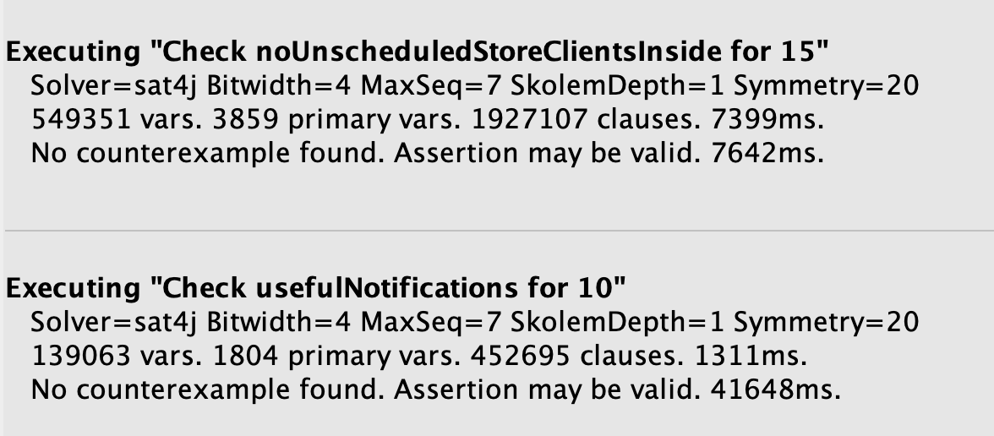

## Alloy generated Worlds

* ***Simple case:*** this first world, shown in Figure 1, models a simple scenario in which a single Store with two departments is registered on CLup. In the instant shown, only one Guest is inside the shop. However, some Customers, who have not yet entered the shop, have scheduled a visit for the current slot. The system correctly marks the slot as not available to avoid overcrowding since the maximum capacity of all the departments has been reached. In the figure, some links and elements have been hidden for easier reading.

**pred** simpleCase{

#Store=1 **and** #Customer=5

#Notification=0 **and** #Department=2

#Visit=5 **and** #Slot=2

}

**run** simpleCase **for** 6

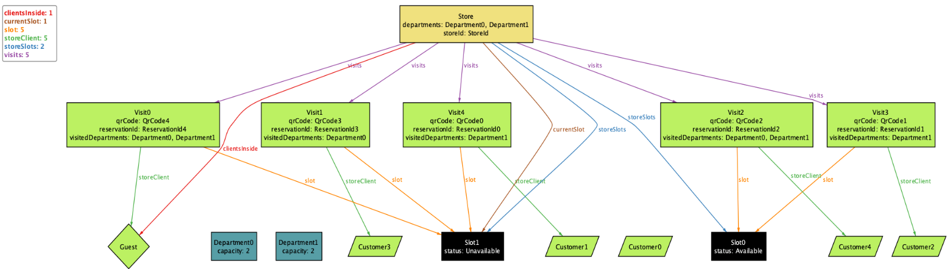

Figure 1: simple case

* ***Multiple Stores:*** this world, shown in Figure 2, models a more complex scenario with more than one Store. In the figure, some links and elements have been hidden for easier reading.

**pred** multipleStores{

#Store=3 **and** #Customer=4

#Notification=0 **and** #Department=5

}

**run** multipleStores **for** 6

Figure 2: multiple stores

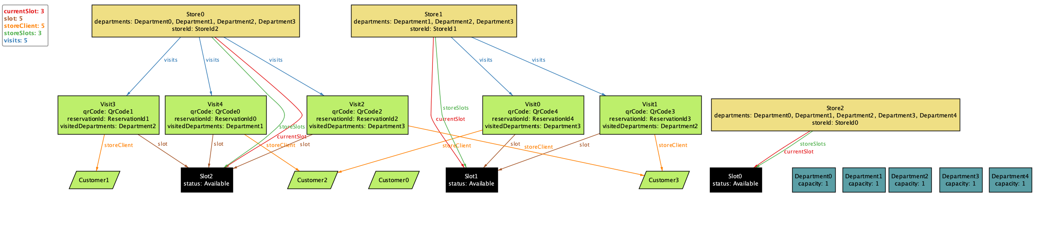

* ***World with notifications***: this world, shown in Figure 3, models a scenario in which various customers are notified of the availability of a slot at a store where they have previously requested a visit. In the figure, some links and elements have been hidden for easier reading.

**pred** worldWithNotifications{

#Store=1 **and** Notification=3

#Visit=5

}

**run** worldWithNotifications **for** 6

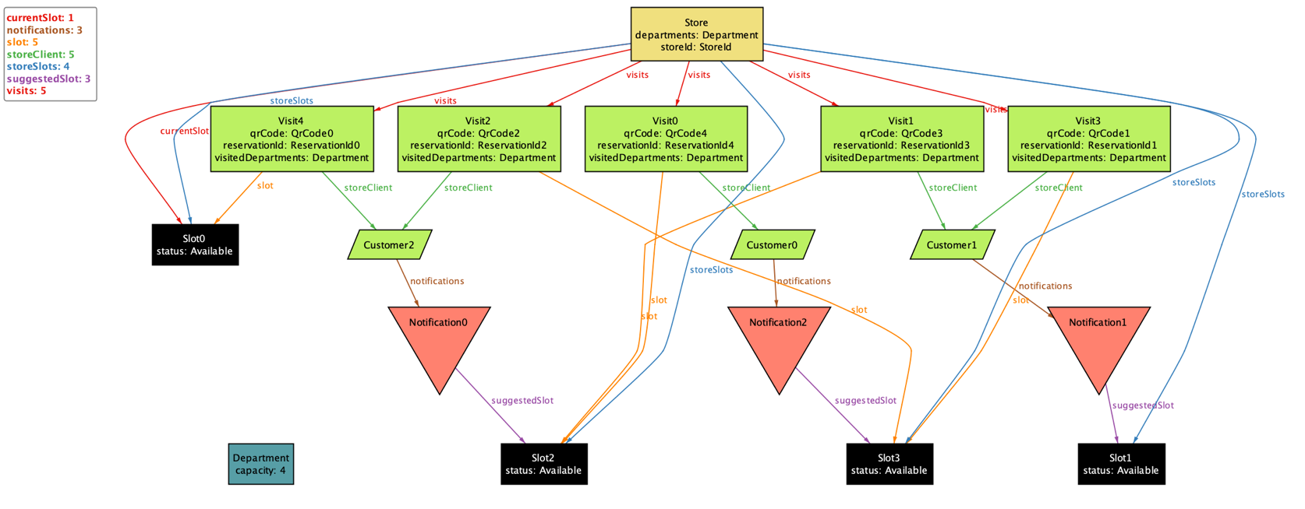

Figure 3: World with notifications

**Chapter 5**

# 5 Effort Spent

The following tables summarize the effort spent by each member of the team to create the RASD document.

## 5.1 Leoni Luca

|  |  |
| --- | --- |
| **Description of the task** | **Hours** |
| Discussion about the Assignment 2020-2021 | 1 |
| Document structure and Scope and Purpose | 2 |
| Revision First chapter, Definition of Scenarios and Product Functions | 2 |
| Scenarios (5-6) | 1 |
| Definition of Use Case and related diagrams | 2 |
| Use Case and Sequence diagrams (draw.io) | 2 |
| User characteristics and Domain Assumptions | 2 |
| User Interfaces | 6 |
| UML and State Charts | 2 |
| Revision Second chapter | 1 |
| Conclusion Third chapter | 2 |
| Alloy: introduction and signatures definition | 4 |
| Alloy: facts definition | 3 |

## 5.2 Locarno Silvia

|  |  |
| --- | --- |
| **Description of the task** | **Hours** |
| Discussion about the Assignment 2020-2021 | 1 |
| Document structure and Scope and Purpose | 3 |
| Revision First chapter, Definition of Scenarios and Product Functions | 2 |
| Scenarios (3-4) | 1 |
| Definition of Use Case and related diagrams | 2 |
| Use Case and Sequence diagrams (draw.io) | 3 |
| Definition of Requirements | 3 |
| Traceability Matrix | 2 |
| UML and State Charts | 2 |
| Revision Second chapter | 1 |
| Conclusion Third chapter | 2 |
| Alloy: introduction and signatures definition | 4 |
| Alloy: facts definition | 2 |
| Revision Third chapter | 2 |

## 5.3 Minotti Luca

|  |  |
| --- | --- |
| **Description of the task** | **Hours** |
| Discussion about the Assignment 2020-2021 | 1 |
| Document structure and Scope and Purpose | 3 |
| Revision First chapter, Definition of Scenarios and Product Functions | 2 |
| Scenarios (1-2-7-8) | 2 |
| Definition of Use Case and related diagrams | 2 |
| Use Case and Sequence diagrams (draw.io) | 1.5 |
| Definition of Requirements | 3 |
| Traceability Matrix | 2 |
| Design Constraints | 1 |
| UML and State Charts | 2 |
| Revision Second chapter | 1 |
| Conclusion Third chapter | 2 |
| Alloy: introduction and signatures definition | 4 |
| Alloy: facts definition and refinements | 5 |

**Chapter 6**

# 6 References

* E. Di Nitto. Lecture Slides. Politecnico di Milano.
* E. Di Nitto. Project Assignment AY 2019-2020. Politecnico di Milano.
* ISO/IEC/IEEE 29148:2011. Standard on requirement engineering. https://standards.ieee.org/standard/29148-2011.html.